Machine Description | A deliberately vulnerable lab machine for practicing web app exploits, privilege escalation, and post-exploitation to gain user and root access.
Target IP | 192.168.0.149
Vulnerability Name | Local File Inclusion (LFI) leading to Remote Code Execution (RCE)  - Privilege Escalation via SUID Misconfiguration (screen-4.5.0)
Port / Service | TCP 80 / http
Severity | High 8.4
Attack Vetor | CVSS:3.0/AV:L/AC:L/PR:N/UI:N/S:U/C:H/I:H/A:H
Proof of Concept (PoC) | STEP 1 – Nmap to find the IP of the target machine.  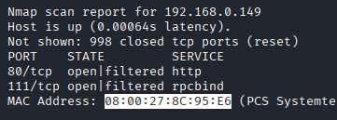  STEP 2 – Nmap Scan to discover open ports and Services  # nmap –p- -sC –sV $ip –open  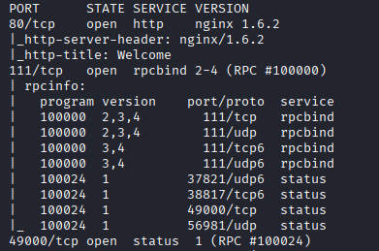  Step 3 – Found a Contact page  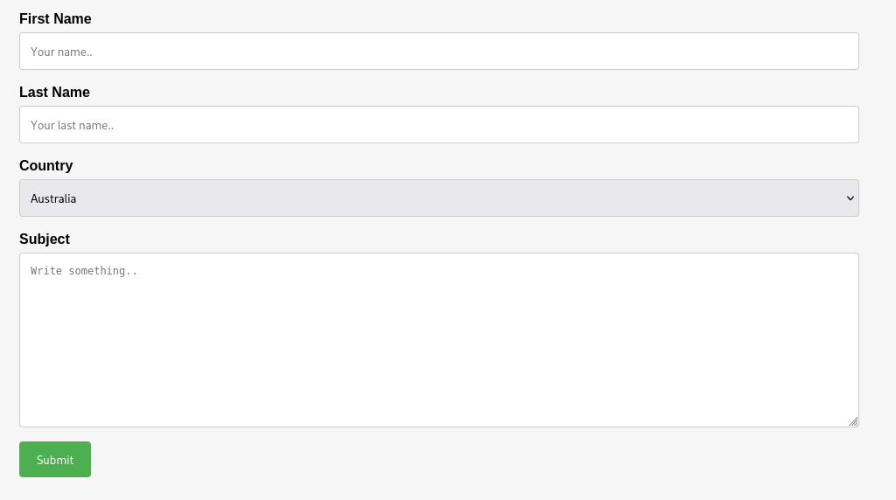  Step 4 - All the data is processed by thankyou.php  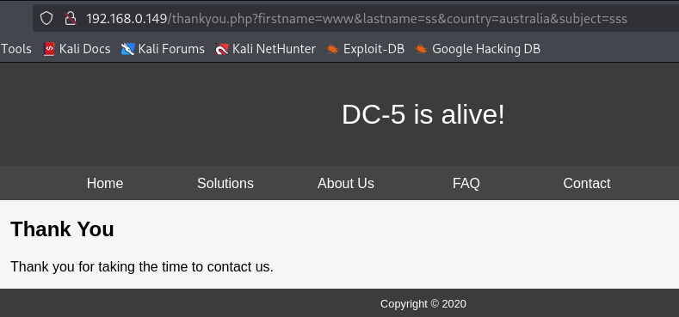  Step 5 – Found a Hidden parameter “file”  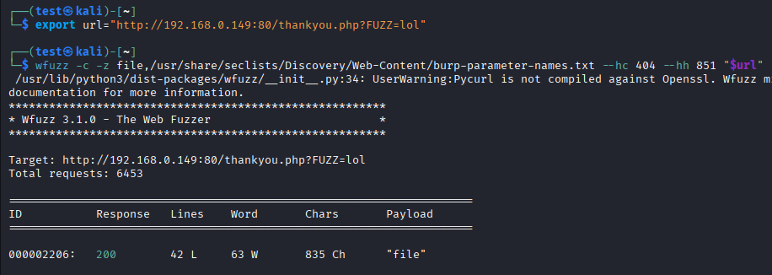  Step 6 -  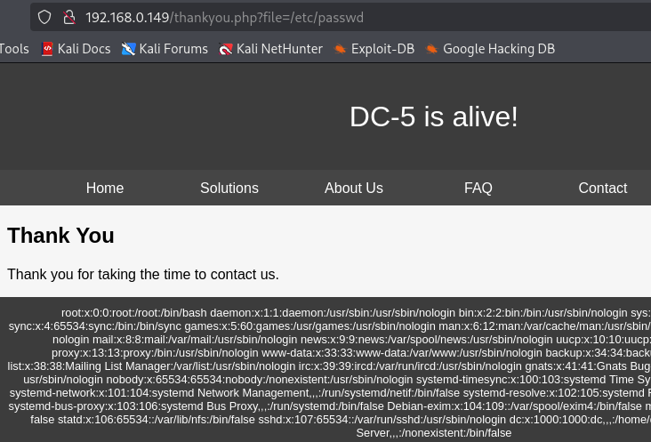  Step 7 – We can access the nginx log files  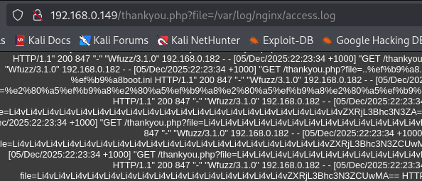  Step 8 - Posined the logs  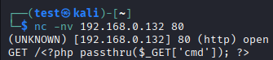  Step 9 – Waiting for connection  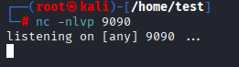  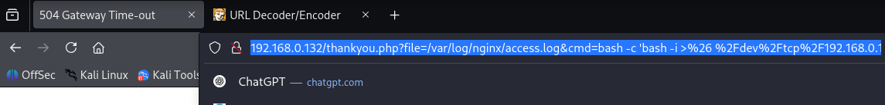  Step 10 - Encoded the command and pasted it in the URL.  Step 11 - We have a shell  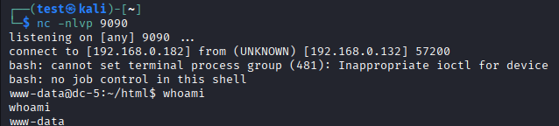  Step 12 - Found a SUID ‘screen-4.5.0’  # find / -perm -u=s -type f 2>/dev/null  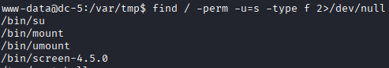  Step 13 – Found the expoilt (exploit name=41154.sh)  Step 14 - Transferred the exploit  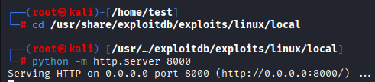  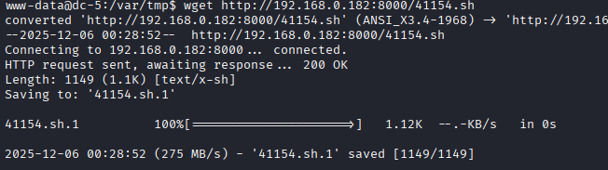  Step 15 - Gave execution permissions  Step 16 – Execute it and we have root  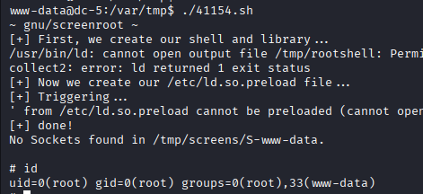  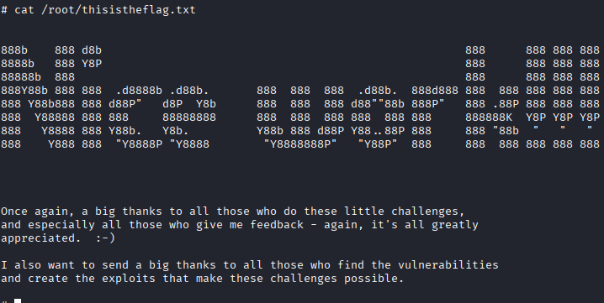  PROOF:  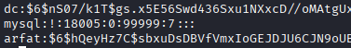  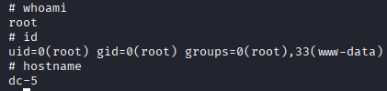
Remediation | • Block unsafe parameters like file=  • Validate all inputs  • Update/remove vulnerable screen-4.5.0  • Remove SUID permissions  • Apply OS and app security patches
Impact | • Attacker can access hidden system files  • Can run commands on the server  • Can become full admin (root)  • Full system takeover and data loss
References | https://owasp.org/www-community/attacks/Local_File_Inclusion  https://owasp.org/www-community/vulnerabilities/Code_Injection  https://owasp.org/www-project-top-ten/

